

DVTK Design Specification
DICOM Object Library

1.0
2005-06-29
Table of Contents
1 Introduction 4
1.1 Purpose 4
1.2 Scope 4
1.3 Audience 4
1.4 Abbreviations and acronyms 4
1.5 References 4
1.6 History 4
2 DICOM object concepts 6
3 Global Design of DICOM object library 7
3.1 Detail Design of DCM Attribute Group Class 8
3.1.1 Adding the Group Length attribute to the DCM attribute group 8
3.1.2 Compute the length of the DCM object 9
3.1.3 Setting the Transfer syntax of all the attributes in a DCM attribute group 9
3.1.4 The operators are used to check following things in a DCM Attribute group. 10
3.1.5 Populate the Type 2 attributes to the DCM attribute group 10
3.1.6 Encoding/Decoding the DCM object to/from Data transfer stream 11
3.1.7 Handling of Private attributes in the DCM attribute group 11
3.1.8 Setting/Getting the offset from the beginning of the network/ file stream. 11
3.1.9 The over-ridden methods in the DCM attribute group class 11
3.2 Detail Design of DCM Dataset class 13
3.2.1 Setting/Getting the Command Id and IOD name 13
3.2.2 Encoding/Decoding the Dataset to/from Data transfer stream 13
3.2.3 Remove the Trailing Padding from the dataset 14
3.2.4 Populate the DICOM Dataset with attributes 14
3.3 Detail Design of DCM Command class 15
3.3.1 Setting/Getting the Command Id 15
3.3.2 Setting/Getting the type of command whether it is a request or response 15
3.3.3 Encoding the Command to Data transfer stream 16
3.4 Detail Design of DCM Item class 17
3.4.1 Setting/Getting the Introducer and Delimiter Group/Element 17
3.4.2 Encoding/Decoding the DICOM Item to/from Data transfer stream 18
3.4.3 Compute the Length of the Item 18
3.5 Detail Design of DCM Attribute class 19
3.5.1 Encoding/Decoding the DICOM Attribute to/from Data transfer stream 20
3.5.2 Operators 20
3.5.3 Replacing the value 20
3.5.4 Set the transfer VR for a DICOM attribute 20
3.5.5 Setting the various user invoked options 20
3.6 Private Attributes Classes 21
3.6.1 Concept of Private Attributes 21
3.6.2 Design Strategy for Private Attributes 21
3.6.3 Private Recognition Code class 22
3.6.3.1 Setting/Getting the In and Mapped Group/Element 22
3.6.3.2 Setting/Getting the recognition code 23
3.6.4 Private Recognition Code Table class 23
3.6.4.1 Managing the recognition code in the list 23
3.6.5 Private Attribute Handler class 24
3.6.5.1 Managing the recognition code tables 24
3.6.6 Handling of Private Attributes in DVT 25

Introduction

Purpose
This document describes the global and detail design of the DICOM object library. This is a living document and changes in the design should be laid down in this document. Especially the sections on detailed design DICOM object classes may change during the project.

Scope
The DICOM object library is the heart of the DICOM Validation Tool. This library defines classes used to describe the main data structure used by the DICOM Validation Tool.

Audience
This document is intended for all the implementers in the DVT project. The reader is assumed to have basic DICOM knowledge.

Abbreviations and acronyms
Abbreviation / acronym | Description
Definition File | File containing the DICOM SOP Class description(s).
DVT | DICOM Validation Tool.
Session File | File containing the test session parameters.
User | Person who is implementing the DICOM object library.

References
Reference | Title | Author/Publisher | Document number
DEFINITION | Definition File Specification | M. van Minderhout | XZS 980-000123.00
SCRIPT | DICOMScript Language Specification | R. Busbridge | XZS 980-000118.00
SESSION | Test Session File Specification | R. Busbridge | XZS 980-000119.00
DESIGNSPEC | DICOM object design specification | R. Busbridge  M. van Minderhout | XZS 980-000183.01
PATTERNS | Design Patterns | E. Gamma et al. | ISBN 0201633612
DCM | DICOM standard 2004 | NEMA | PS 3.0-2004

History
Version | Date | Author | Description
0.1 | 22 April 2005 | Piyush Bhageriya  Manisha Singla | Initial version
1.0 | 29 June 2005 | Piyush Bhageriya  Manisha Singla | Update for OpenSource release

DICOM object concepts
The DICOM Objects is used to describe the main data structure used by the DICOM Validation Tool. The DICOM object will be implemented as an array of attributes.
The DICOM Objects are generated by following means:
- Parsing the contents of DICOM Scripts
- Reading the DICOM stream from the network
- Reading the DICOM stream from the file
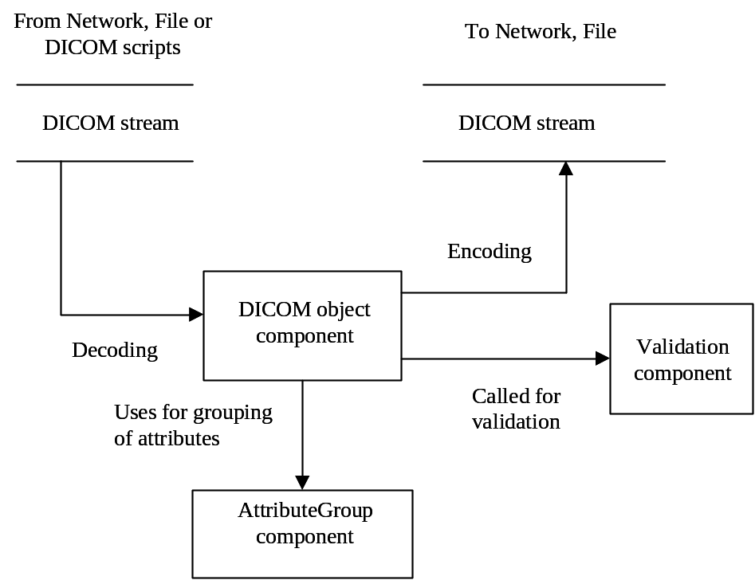

Figure 1 Basic relationship diagram of DICOM object library

The DICOM object library manages all data concerning the grouping of attributes and the attributes itself using the AttributeGroup library. These objects can be written to Network or File Transfer and also can be stored in warehouse for further use. These objects can be validated against the definitions and reference (expected) objects.

Global Design of DICOM object library
This paragraph describes the relationship between various classes of the DICOM object library (see figure 2).
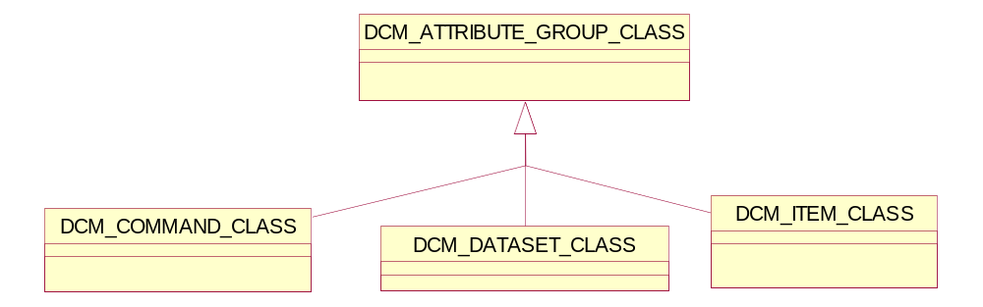

Figure 2 DICOM object classes

The classes DCM_COMMAND_CLASS, DCM_DATASET_CLASS and DCM_ITEM_CLASS will be derived from the DCM_ATTRIBUTE_GROUP_CLASS will also be used during validation. These classes should be instantiated as a result of data received over the network, data read from file or data provided by the Scripting library. These objects can then be validated against the Definition library information and also equated with each other.
The DCM_COMMAND_CLASS will represent all DICOM Command. E.g., C-STORE-RQ or N-GET-RSP.
The DCM_DATASET_CLASS will represent all DICOM Datasets. E.g., CR Image, Printer Status.
The DCM_ITEM_CLASS will represent all DICOM Items. E.g., Referenced Patient Sequence Item. Recursion is introduced in the CLASS hierarchy because the ITEM_CLASS will be one of the possible attribute value classes.

Detail Design of DCM Attribute Group Class
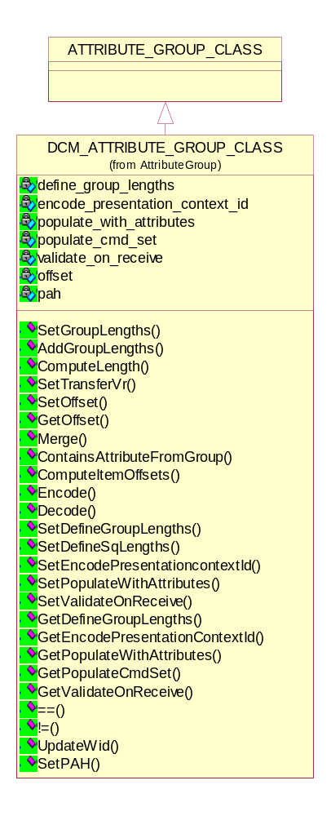
Figure 3 DCM Attribute group class

Adding the Group Length attribute to the DCM attribute group
The Group Length (gggg,0000), the standard data element shall be implicitly defined for all attribute groups with VR of UL and a VM of 1. It is an optional attribute and DVT provides the following options to the user to define group length in an attribute group.
The AddGroupLength option is used to add Group Length attributes to all Groups found in each message sent. This includes Group within Items in Sequences. The Group Length for the DCM_COMMAND_CLASS is added by default as this is mandatory in DICOM.

- Setting the define group length option in a DCM attribute group
void setDefineGroupLengths(bool flag);
This is the method to set the group length flag for all attributes. By default DVT does not encode Group Length attributes (Except for the Command Group Length).

- Getting the define group length option in a DCM attribute group
bool getDefineGroupLengths();

- Setting the group length of DCM attribute group
void setGroupLengths(TS_CODE tsCode);
This is the method to compute the value of the Group Length attributes. It is necessary to know the Transfer Syntax used for encoding when computing the Group Lengths.

- Adding the group length attribute to the DCM attribute group
void addGroupLengths();
This is the method to add the Group Length attributes to the DICOM object. They are initially filled in with a zero length. The actual lengths need to be computed when the sequence lengths are known just before encoding the message.

The DefineSqLength option is used to encode explicit length Sequences when sending messages. Explicit lengths are computed for both the Sequence and each Item present within the Sequence.
By default DVT uses the undefined length encoding for Sequences and Items.

- Setting the define sequence length option in a DCM attribute group
void setDefineSqLengths(bool flag);
This is the method to set the sequence length flag for all sequence attributes.

- Getting the define sequence length option in a DCM attribute group
bool getDefineSqLengths();

Compute the length of the DCM object
UINT32 computeLength(TS_CODE tsCode);
This is the method to compute the length of the object. This method maybe called recursively.

Setting the Transfer syntax of all the attributes in a DCM attribute group
void setTransferVR(TRANSFER_ATTR_VR_ENUM transferVr);
This is the method to set the transfer VR for all attributes. This is used in order to set up the correct VR for logging purposes on send.

The operators are used to check following things in a DCM Attribute group.
- The number of attributes in the group must be the same.
- The attributes order is assumed to be the same in both objects.
- Each attribute tag (group/element) and contents must be the same.

  - Equality operator
bool operator == (DCM_ATTRIBUTE_GROUP_CLASS &that);

Return value | Explanation
true | The DCM attribute groups are equal.
false | The DCM attribute groups are not equal.

- Non-equality operator
bool operator != (DCM_ATTRIBUTE_GROUP_CLASS &that);

Return value | Explanation
true | The DCM attribute groups are not equal.
false | The DCM attribute groups are equal.

Populate the Type 2 attributes to the DCM attribute group
The Populate with attribute option is used to enable / disable the automatic addition of Type 2 attributes during object creation. This ensures that objects used by DVT will conform to the DICOM Standard without the User having to explicitly define values for all Type 2 attributes. This option can be set by the user through scripts using POPULATE command.

- Setting the Populate With Attributes option in a DCM attribute group
void setPopulateWithAttributes(bool flag);

- Getting the Populate With Attributes option in a DCM attribute group
bool getPopulateWithAttributes();

Return value | Explanation
true | With the POPULATE switch enabled (ON), the CREATE command will automatically add Type 2 attributes with a zero-length during object creation.
false | With the POPULATE switch disabled (OFF), the CREATE command will not automatically add any attributes during object creation.

Encoding/Decoding the DCM object to/from Data transfer stream
Both the methods are virtual and over-ride able by the derived classes. The ITEM, COMMAND and DATASET classes implement these methods according to their specific needs. The DATA_TF_CLASS provides the necessary Transfer Syntax details for the encoding/decoding.

- Encoding the DCM object to Data transfer stream
virtual bool encode(DATA_TF_CLASS&);

- Decoding the DCM object from Data transfer stream
virtual bool decode(DATA_TF_CLASS&, UINT16 lastGroup = LAST_GROUP, UINT16 lastElement = LAST_ELEMENT, UINT32 *length_ptr = NULL);

Return value | Explanation
true | The encoding/decoding completed successfully.
false | The encoding/decoding failed.

Handling of Private attributes in the DCM attribute group
DVT handles the Private Attributes a DICOM object using a Private Attribute Handler (PAH) – see section 3.6.

- Setting the Private Attribute Handler
void setPAH(PRIVATE_ATTRIBUTE_HANDLER_CLASS*);

- Getting the Private Attribute Handler
PRIVATE_ATTRIBUTE_HANDLER_CLASS* getPAH();

Setting/Getting the offset from the beginning of the network/ file stream.
These methods are needed when computing the offsets in the DICOMDIR record structures.

- Setting the offset
void setOffset(UINT32 offset);

- Getting the offset
UINT32 getOffset();

The over-ridden methods in the DCM attribute group class

void setValue(UINT32, BYTE*);
void addATValue(UINT32, UINT32);
void setCSValue(UINT32, string);
void setDAValue(UINT32, string);
void setLOValue(UINT32, string);
void setOBValue(UINT32, UINT, UINT);
void setOBValue(UINT32, UINT, UINT, BYTE);
void setTMValue(UINT32, string);
void setUIValue(UINT32, string, bool replaceFirst = true);
void setUSValue(UINT32, UINT16, bool replaceFirst = true);

bool getATValue(UINT32 tag, int index, UINT32 *data_ptr);
bool getCSValue(UINT32, BYTE*, UINT);
bool getCSValue(UINT32 tag, string& data, int index = 0);
bool getDAValue(UINT32, BYTE*, UINT);
bool getISValue(UINT32, INT32*);
bool getLOValue(UINT32, string&);
bool getPNValue(UINT32, string&);
bool getSQValue(UINT32, DCM_VALUE_SQ_CLASS**);
bool getSTValue(UINT32, BYTE*, UINT);
bool getTMValue(UINT32, BYTE*, UINT);
bool getUIValue(UINT32, string&);
bool getULValue(UINT32, UINT32*);
bool getUSValue(UINT32, UINT16*);

void addAttribute(DCM_ATTRIBUTE_CLASS*);
DCM_ATTRIBUTE_CLASS *GetAttribute(UINT16, UINT16);
DCM_ATTRIBUTE_CLASS *GetAttribute(int);
DCM_ATTRIBUTE_CLASS *GetAttributeByTag(UINT32);
bool containsAttributesFromGroup(UINT16);

These methods provide get/set access to the attributes of various VR types in the DCM_ATTRIBUTE_GROUP_CLASS.
Additional methods provide search options for DCM_ATTRIBUTE_CLASS instances in the DCM_ATTRIBUTE_GROUP_CLASS.

Detail Design of DCM Dataset class
The dataset (IOD) is specific for a command. The attributes are grouped by module; within the module the attributes are ordered ascending on attribute tag.
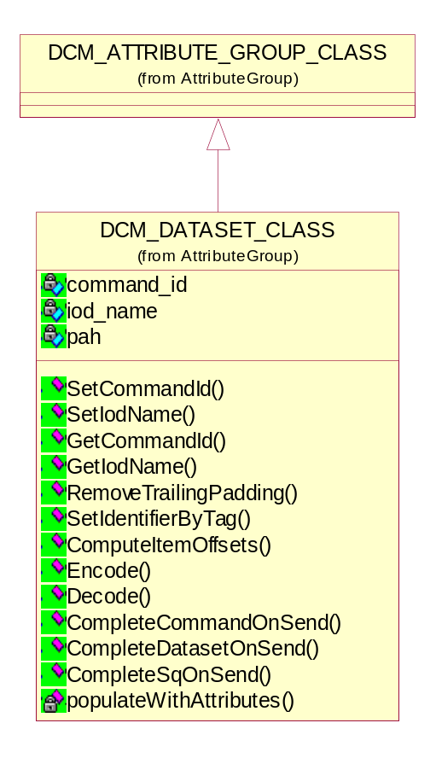
Figure 4 DCM Dataset class

Setting/Getting the Command Id and IOD name
These names are used for Definition look-up and Warehouse storage.

- Setting the Command Id and IOD name
void setCommandId(DIMSE_CMD_ENUM commandId);
void setIodName(char *iodName_ptr);

- Getting the Command Id and IOD name
DIMSE_CMD_ENUM getCommandId();
const char* getIodName();

Encoding/Decoding the Dataset to/from Data transfer stream
This class overrides both the methods.

- Encoding the DICOM Dataset to Data transfer stream
bool encode(DATA_TF_CLASS&);

- Decoding the DICOM Dataset from Data transfer stream
bool decode(DATA_TF_CLASS&, UINT16 lastGroup = 0xFFFF);

Return value | Explanation
true | The encoding/decoding completed successfully.
false | The encoding/decoding failed.

Remove the Trailing Padding from the dataset
void removeTrailingPadding();
This is the method to remove Trailing Padding from the dataset.

Populate the DICOM Dataset with attributes
void populateWithAttributes();
This is the Method to ensure that the dataset sent is complete - at least zero length attributes sent for all Type 2.

Detail Design of DCM Command class

DVT supports all the DICOM Command defined in DICOM Standard Part-4.
DICOM Command:
C-ECHO-RQ, C-ECHO-RSP,
C-FIND-RQ, C-FIND-RSP,
C-GET-RQ, C-GET-RSP,
C-MOVE-RQ, C-MOVE-RSP,
C-STORE-RQ, C-STORE-RSP,
C-CANCEL-RQ,
N-ACTION-RQ, N-ACTION-RSP,
N-CREATE-RQ, N-CREATE-RSP,
N-DELETE-RQ, N-DELETE-RSP,
N-GET-RQ, N-GET-RSP,
N-SET-RQ, N-SET-RSP,
N-EVENT-REPORT-RQ, N-EVENT-REPORT-RSP
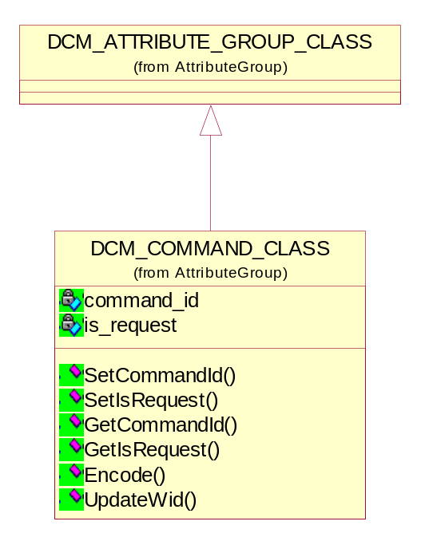
Figure 5 DCM Command class

Setting/Getting the Command Id

- Setting the Command Id
void setCommandId(DIMSE_CMD_ENUM commandId);

- Getting the Command Id
DIMSE_CMD_ENUM getCommandId();

Setting/Getting the type of command whether it is a request or response

- Setting the Command type
void setIsRequest(bool flag);

- Getting the Command type
bool getIsRequest();

Return value | Explanation
true | The command is the request command e.g. C-STORE-RQ.
false | The command is the response command e.g. C-STORE-RSP.

Encoding the Command to Data transfer stream
This class overrides this method.

- Encoding the Command to Data transfer stream
bool encode(DATA_TF_CLASS&);

Return value | Explanation
true | The encoding completed successfully.
false | The encoding failed.

Detail Design of DCM Item class
The value representation ‘SQ’ shall be used for Attributes with a values consisting of a sequence of zero or more items, where each item contains a group of e.g., Referenced Patient Sequence Item. Recursion is introduced in the class hierarchy because the DCM Item class will be one of the possible attribute value classes.
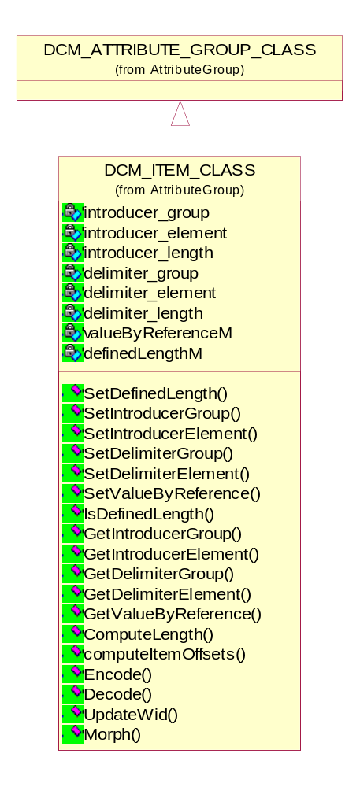
Figure 6 DCM Item class

Setting/Getting the Introducer and Delimiter Group/Element

- Setting the Introducer and Delimiter Group/Element
void setIntroducerGroup(UINT16 group);
void setIntroducerElement(UINT16 element);
void setDelimiterGroup(UINT16 group);
void setDelimiterElement(UINT16 element);

- Getting the Introducer and Delimiter Group/Element
UINT16 getIntroducerGroup();
UINT16 getIntroducerElement();
UINT16 getDelimiterGroup();
UINT16 getDelimiterElement();

Encoding/Decoding the DICOM Item to/from Data transfer stream
This class overrides both the methods.

- Encoding the DICOM Item to Data transfer stream
bool encode(DATA_TF_CLASS&);

- Decoding the DICOM Item from Data transfer stream
bool decode(DATA_TF_CLASS&, UINT16 lastGroup = ITEM_GROUP, UINT16 lastElement = LAST_ELEMENT, UINT32 *length_ptr = NULL);

Return value | Explanation
true | The encoding/decoding completed successfully.
false | The encoding/decoding failed.

Compute the Length of the Item

- Length of the Item
UINT32 DCM_ITEM_CLASS::computeLength(TS_CODE tsCode)
This is the method to compute the length of the item.

Detail Design of DCM Attribute class
The DCM attribute class knows everything about a single streamed attribute: group, element, VR and type of the attribute. For each of these values, functions are available to set and get the value.
The ATTRIBUTE_CLASS will be implemented as an array of abstract BASE_VALUE_CLASS. There can be zero, one or more elements in the array depending on how many values the attribute has. A “zero-length” attribute will have no values.
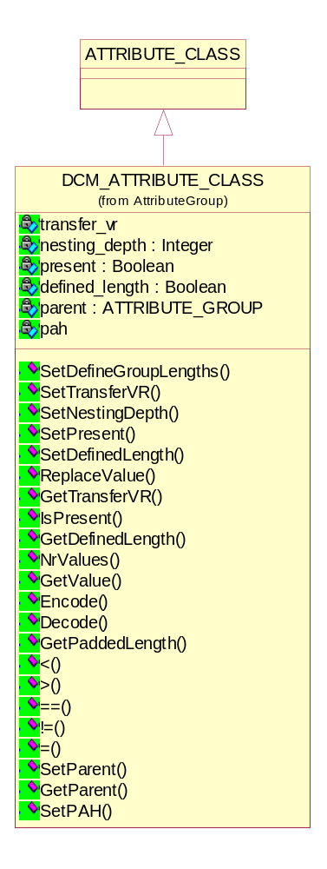
Figure 7 DCM Attribute class

Encoding/Decoding the DICOM Attribute to/from Data transfer stream
The encoding of DICOM attributes should be done according to [DCM] Part 5. All the encoding rules, exceptions and all possibilities should be taken into account during implementation of following methods.
- Encoding the DICOM Attribute to Data transfer stream
bool encode(DATA_TF_CLASS&);

- Decoding the DICOM Attribute from Data transfer stream
bool decode(DATA_TF_CLASS&, UINT16, UINT16, UINT32*);

Return value | Explanation
true | The encoding/decoding completed successfully.
false | The encoding/decoding failed.

Operators
- Operators which operate on the source and destination attributes on the basis of their tags
<, >, == and !=
These operators compare the attribute tag on the left side of the operator with the attribute tag on the right side of the operator. Depending on the operator and the attribute tags, the operator will be true or false.
- Operator which operates on the source and destination attributes on the basis of their values
bool operator = (DCM_ATTRIBUTE_CLASS&);
These operators compare the attribute values on the left side of the operator with the attribute values on the right side of the operator. Depending on the attribute values, the operator will be true or false.

Replacing the value
bool replaceValue(int index, BASE_VALUE_CLASS *value_ptr);
This function is used to replace the indexed attribute value with the given value.

Set the transfer VR for a DICOM attribute
void setTransferVR(TRANSFER_ATTR_VR_ENUM transferVr);
This function is used to set the transfer VR - this parameter is used to indicate how an attribute should be encoded - implicit, explicit, unknown or using question marks.

Setting the various user invoked options
void setDefinedLength(bool flag);
void setDefineGroupLengths(bool flag)
void setNestingDepth(int nestingDepth)
These functions set various user option and all these lengths setting used during encoding\decoding of attributes.

Private Attributes Classes

Concept of Private Attributes
The user may require communication of information that cannot be contained in standard DICOM attributes so private attributes are intended to contain such information.
Private Creator Attributes numbered (gggg,0010-00FF) shall be used to reserve a group of attributes with Group Number gggg (gggg is odd) for use by an individual implementer. The implementer shall insert a recognition code in the first unused (unassigned) Element in this series to reserve a block of Private Attributes. The VR of the private identification code shall be LO (Long String) and the VM shall be equal to 1.
Private Creator Attribute (gggg,0010), is a Type 1 attribute that identifies the implementer reserving element (gggg,1000-10FF), Private Creator Attribute (gggg,0011) identifies the implementer reserving elements (gggg,1100-11FF), and so on, until Private Creator Attribute (gggg,00FF) identifies the implementer reserving elements (gggg,FF00-FFFF).
Encoders of Private Attributes shall be able to dynamically assign private data to any available (unreserved) block(s) within the Private group, and specify this assignment through the blocks corresponding Private Creator Attribute(s). Decoders of Private Data shall be able to accept reserved blocks with a given Private Creator recognition code at any position within the Private group specified by the blocks corresponding Private Creator Attribute.

Design Strategy for Private Attributes
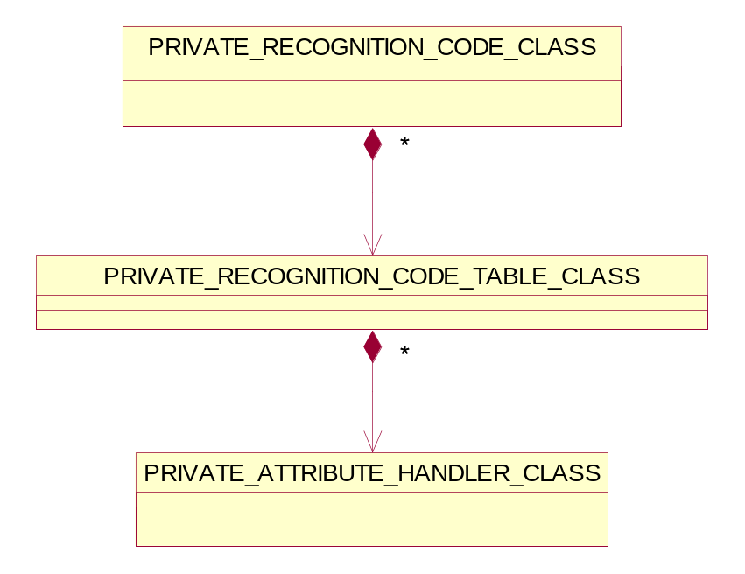
Figure 8 General classes for Private Attribute Handling
The Private Recognition Code class will represent the recognition codes defined by in the Definition File corresponding to the SOP Class Dataset. The Private Recognition Code Table class will maintain all the recognition codes in a table. The Private Attribute Handler class will provide the interface to DICOM object library and other libraries for handling of Private Attributes.

Private Recognition Code class
Private attributes must be accompanied by a Recognition code. The Private Creator Codes (gggg,0010) to (gggg,00FF) must be defined by the User. While streaming the private attributes, this class dynamically maps private attribute to any available (unreserved) block(s) within the Private group, and specify this assignment through the blocks corresponding Private Creator Attribute(s).
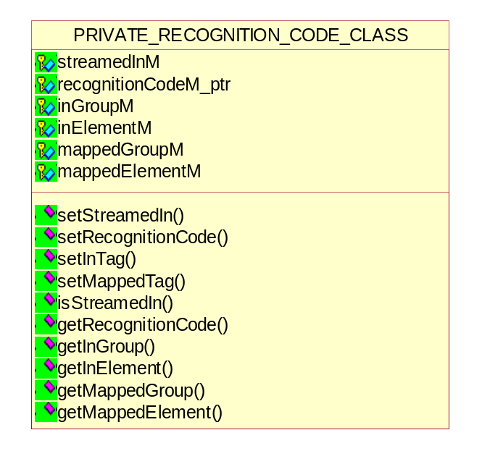
Figure 9 Private Recognition Code class

Setting/Getting the In and Mapped Group/Element

- Setting the In and Mapped Group/Element
void setInTag(UINT16 group, UINT16 element);
void setMappedTag(UINT16 group, UINT16 element);

- Getting the In and Mapped Group/Element
UINT16 getInGroup();
UINT16 getInElement();
UINT16 getMappedGroup();
UINT16 getMappedElement();

On decoding a dataset containing private attributes, DVT will try to map the incoming recognition code to one defined in the Definition File for this SOP Class.
Example: Incoming recognition code (0091,0021) with value “DVT Private Attributes”.
DVT will search the PRIVATE_RECOGNITION_CODE_TABLE_CLASS for an entry matching “DVT Private Attributes”. The Group / Element associated with this recognition code will then be used to further decode the incoming private attributes for validation.
If the definition for the recognition code is (0091,0010) then all incoming tags in the range (0091,21xx) will be mapped to (0091,10xx). The mapped tag will be used for attribute look-up when validating the contents.
If no matching recognition code can be found the incoming tags for the range (0091,21xx) will be mapped to (0091,FFxx) and the tags will not be further validated.

Setting/Getting the recognition code

- Setting the recognition code
void setRecognitionCode(BYTE*);

- Getting the recognition code
BYTE *getRecognitionCode();

Private Recognition Code Table class
The Private Recognition Code Table class will be implemented as an array of Private Recognition Code class. This class will maintain the list of Recognition Codes defined by user.
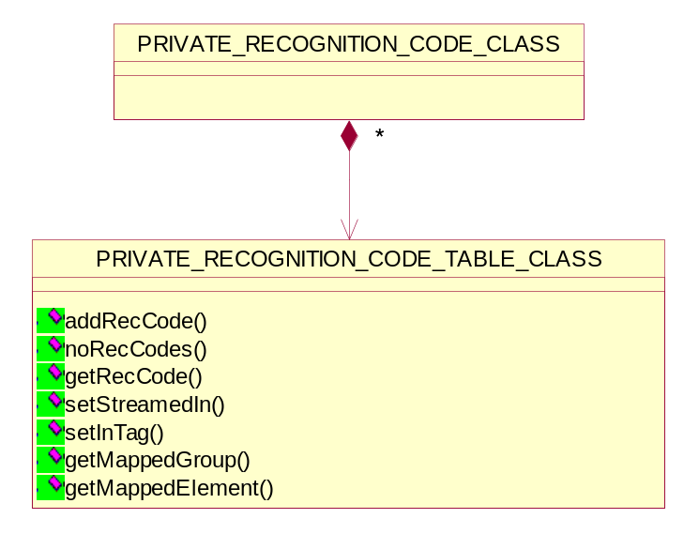
Figure 10 Private Recognition Code Table class

Managing the recognition code in the list

- Adding the new recognition code to the table
void addRecCode(PRIVATE_RECOGNITION_CODE_CLASS recCode);

- Getting the number of recognition codes in the table
UINT noRecCodes();

- Setting the indexed streamed recognition code
bool setStreamedIn(UINT i, bool streamedIn);
Return value | Explanation
true | The indexed entry streamed in is set successfully.
false | The indexed entry streamed in is not set.

- Getting the indexed recognition code
PRIVATE_RECOGNITION_CODE_CLASS& getRecCode(UINT i);

Private Attribute Handler class
The Private Attribute handler class will be implemented as an array of Private Recognition Code Table class. This class will maintain the list of Recognition Code Tables.
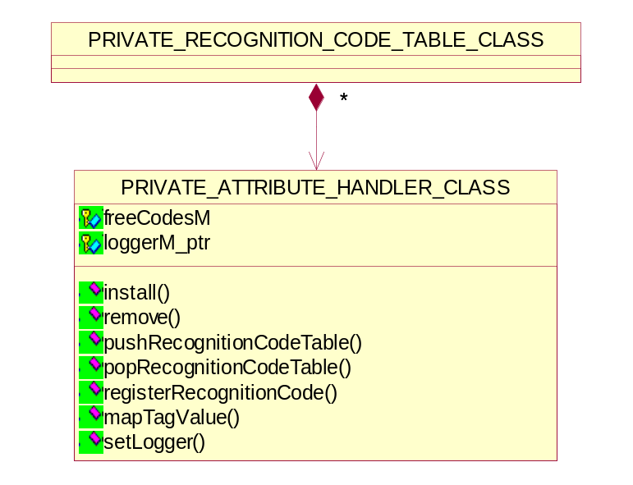
Figure 11 Private Attribute Handler class

Managing the recognition code tables

- Installing the initial recognition code table on the top of the stack
bool install();

- Clean up the recognition code tables
bool remove();

- Initialize new recognition code table and push it onto the stack
bool pushRecognitionCodeTable();

- Pop current recognition code table off the stack and remove it
bool popRecognitionCodeTable();

- Register a private recognition code
bool registerRecognitionCode(BYTE*, UINT16, UINT16, UINT16*, UINT16*);

- Map private tag to base private tag using recognition code provided
bool mapTagValue(UINT16, UINT16, UINT16*, UINT16*);

Handling of Private Attributes in DVT
DVT handles the private attributes in two ways:
- Modified Definition Files - A Private Definition File can be used to specify the private attribute in the same way as any standard attribute. When the private attribute is used in a DICOM Script, DVT will consult the Definition File for the VR, VM, allowed values and attribute name.
- Explicit description in DICOM Script - The private attribute VR can be explicitly defined in the DICOM Script. DVT will then use this VR to encode/decode the attribute values.

